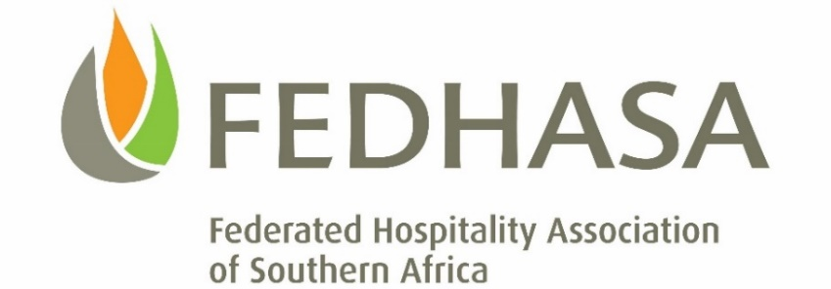

COVID-19: UPDATED TERS-UIF APPLICATION PROCESS

Dear Members

Many employers have reported that they have had trouble accessing the UIF COVID-19 assistance portal.

The application process has been updated and we hope that it will iron out the many difficulties employers have had with the submission of the Excel/CSV files. There is also a new ‘Easy Application Guide’, as well as an ‘On-Line Guide Document’.

Links to these documents can be downloaded by clicking the respective links below:
- https://mcusercontent.com/465a729d2e475cac8d0207c4f/files/496ee2fe-86bb-4c0a-980b-c11cf9c1ae96/Easy_Guide_1.pdf
- https://mcusercontent.com/465a729d2e475cac8d0207c4f/files/ee95d24d-7ca2-4136-bf38-3fa75a24247a/On_line_guide_document.pdf

The system has also been updated with on only one date to select – 27 March to 30 April.

Click here for applications via the TBCSA link

FEDHASA members who have already submitted an application for assistance to the COVID-19 TERS Fund, are not required to re-submit unless requested to do so by the UIF. You may, however, log your submission onto the TBCSA portal on: covid19ters.typeform.com/to/ID2BOH. This will allow the TBCSA and its members associations to monitor the progress of your application.

Hospitality Greetings

Lee Zamekile Zama
CEO: FEDHASA

