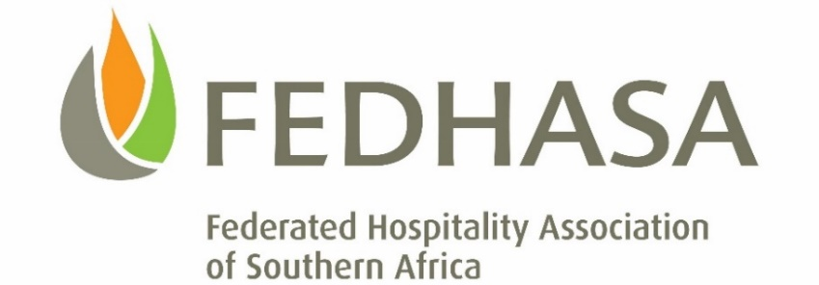

COVID-19: UIF – TERS Update

Dear Members

The month end is near and causing a lot of stress amongst our members to get their UIF submissions and payments sorted. To this end, we are trying our utmost to keep you updated with ever-changing developments. Together with the TBCSA, we are working very hard to facilitate and track all industry applications with the UIF. The UIF has received many queries and we are trying our utmost to keep them on their promised delivery times.

The UIF website now allows for checking the progress of the applications. Those that have applied, can now track the status of their applications and the allocation of the payments.

For all new applications, please click here - https://uifecc.labour.gov.za/covid19/.

Hospitality Greetings

Lee Zamekile Zama
CEO: FEDHASA

