GOLF ENTRY FORM:



23rd Annual Golf Day

Thursday 16th April 2020 at Stellenbosch Golf Club.

Please reply by no later than Thursday 9th April 2020:
Tel.: 021-552 9870 / Fax: 021-552 3466 / E-mail: fedhasacape@fedhasa.co.za

COMPANY & CONTACT: ______________________________________________ DATE: ___________________

Competition: 4 Ball Alliance, 2 scores to count Tee-off from 12h00 till 13h50

Please indicate preferred tee-off time: ______________ @ 1st? _________ or 10th tee? __________

Player 1: Player 2: Player 3: Player 4:

First Name: ____________________ ____________________ ____________________ ____________________

Surname: ____________________ ____________________ ____________________ ____________________

Handicap: ____________________ ____________________ ____________________ ____________________

Club: ____________________ ____________________ ____________________ ____________________

Company: ____________________ ____________________ ____________________ ____________________

Fax/E-mail: ____________________ ____________________ ____________________ ____________________

RULES:
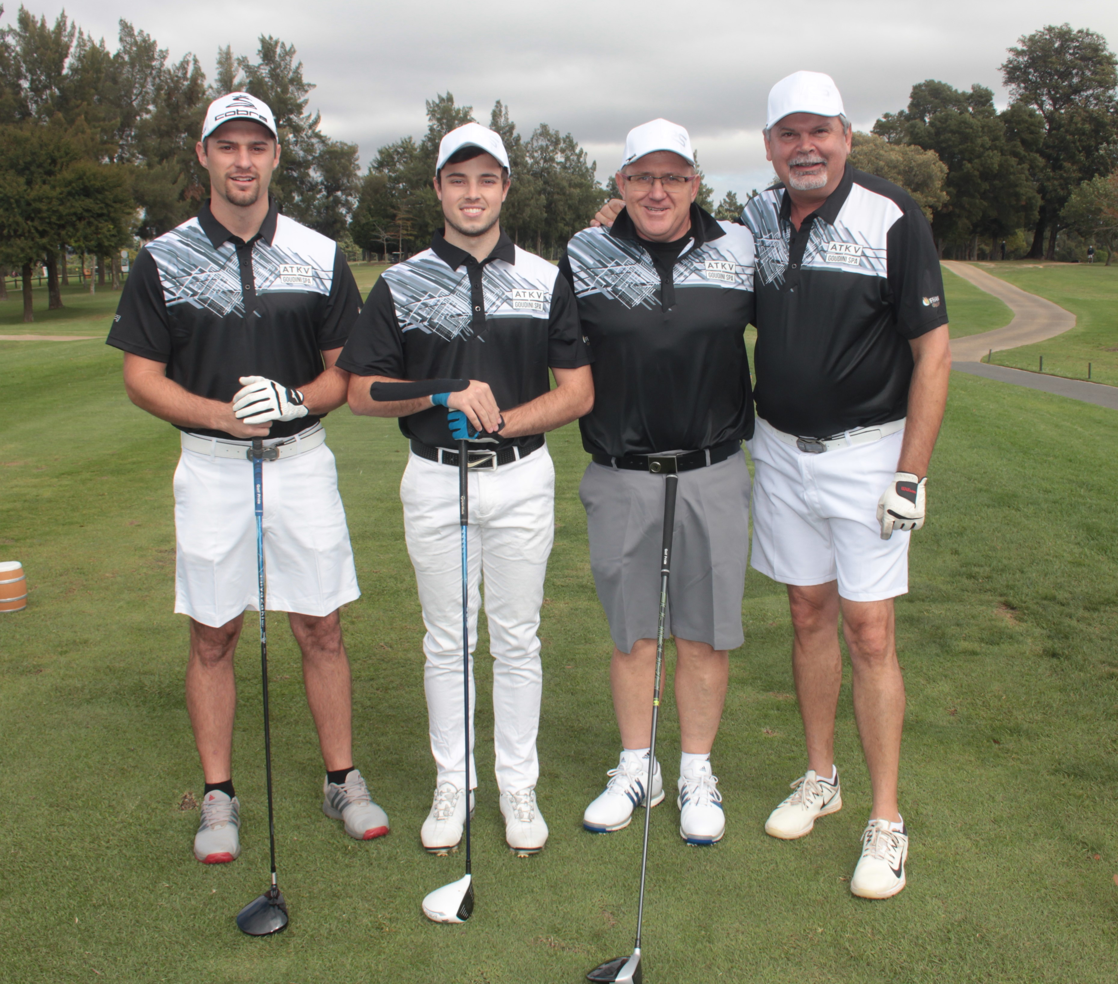
- Maximum official handicaps - Men: 18, Ladies: 24
- Single players also welcome – 4-Ball partners will be allocated and 4-Ball assigned
- Registration: from 10h30
- Tee-off time: from 12h00 till 14h00
- Cost: R5, 200.00 per 4-ball / R1 300.00 pp (VAT incl.) – includes green fees, halfway, dinner & prizes
- Prize-Giving will be held at the top function venue from 18h00/18h30.
- Golf Carts: Please book directly with the Pro-shop on: 021 880 0103
- Dress Code: Club & Golf Course: collared, smart casual or golf shirts – no T-shirts; long- or 3-quarter pants,
soft spikes only; no cell phones on course

FABULOUS PRIZES TO BE WON & LOTS OF FUN!

NB: PRE-PAYMENT WILL SECURE YOUR BOOKING:

For Bank Transfer: (Please also forward proof of deposit to fedhasacape@fedhasa.co.za)

Bank: Nedbank, Stellenbosch (198-765) Acc. Name: FEDHASA Cape Acc. No.: 1498-092-810

