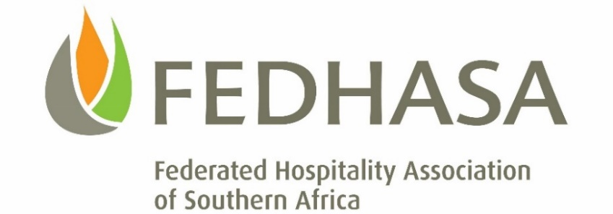

COVID-19: URGENT UPDATE
High Priority for certain Accommodation Establishments

Dear Members

The Minister of Health has published an extension to the Directive providing, in the main, for matters concerning health professionals and personnel. Please in particular, refer to section 9 that deals with visitors from outside South Africa and provides that:

Visitors from outside South Africa
9. (1) All accommodation providers who have visitors from areas outside the Republic residing on their premises must provide a list of such visitors, including their Names, Contact details and Nationality, to the National Department of Health within 24 hours of publication of this Direction – i.e. by Thursday 9th April at 14h00.

(2) All such visitors must be placed under quarantine at the accommodation establishment where they are residing and undergo temperature monitoring on a daily basis for a period of 14 days or any number of days determined by the attending health officials.

Those members who have not as yet forwarded their information, please do so -

CLICK HERE to upload your guest information (CSV separated value format) into the central database by not later than Thursday 9th April at 14h00.

You also have to make contact with either your Provincial Department of Health or your Municipal Department of Health, as the National Department of Health intends to arrange for local health officials to attend the visiting foreign nationals.

National hotline: 0800 029 999 / WhatsApp: 060 012 3456 / www.health.gov.za

Please CLICK HERE to access the full Gazette.

Hospitality greetings

Lee Zamekile Zama
CEO FEDHASA

